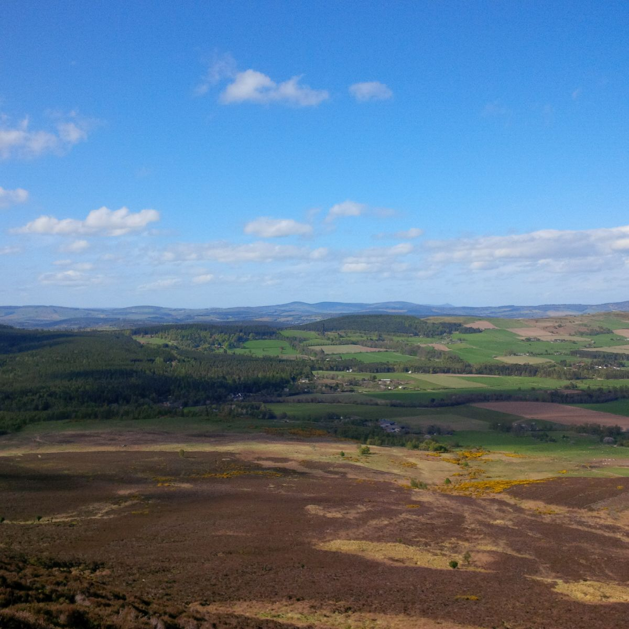thematic

­­­

**Map 1: Employment change between 2001 and 2011**

**Multi-Level Case Study Selection**

M 2.3, Milestone report, March 2024

Scotland’s Land Reform Futures project, Rural Futures theme

Naomi Beingessner and Fiona Bender, SEGS Department, James Hutton Institute

Ian Merrell, James Glendinning, and Lorna Pate, Scotland’s Rural College

March 2024

Photo © The James Hutton Institute

This report was supported by the Rural & Environment Science & Analytical Services Division of the Scottish Government, as part of the Strategic Research Programme 2022-2027.

**Multi-Level Case Study Selection**

M 2.3, Milestone report, March 2024

*Naomi Beingessner and Fiona Bender, SEGS Department, James Hutton Institute*

*Ian Merrell, James Glendinning, and Lorna Pate, Scotland’s Rural College*

# Contents

Contents i

Highlights ii

Research context and objectives 1

Approach taken 2

Main outcomes 5

Next steps 6

**Contact and feedback** 6

**Acknowledgements:**

This work was supported by the [Scottish Government Strategic Research Programme 2022 to 2027](https://www.gov.scot/publications/environment-agriculture-and-food-strategic-research-2022-27-overview/pages/strategic-research-programme-2022-to-2027/).

Thank you to the Stakeholder Advisory Group of the ‘Scotland’s Land Reform Futures’ project for their valuable suggestions.

# Highlights

**What were we trying to find out?**

This report is part of Work Package 2 in the Scotland's Land Reform Futures project under the umbrella of the 'Rural Futures' theme in the Scottish Government's Strategic Research Programme (2022-2027). The project will provide new knowledge regarding land reform, community land ownership and engagement in land use decision-making, as well as increasing understanding of the role of land ownership and land reform in achieving net zero emissions and reversing biodiversity decline in Scotland. This Work Package aims to facilitate understanding of how land reform policies can achieve more equitable and effective land use changes. As part of this, we ask, “What Scottish Government policy goals do alternative models of tenure and access (through ownership, governance, or other) address, and what contributes to or is a barrier to their success”?

**What did we do?**

We generated a long-list of landscape/regional level organisations and initiatives relevant to land-based governance in Scotland and a long-list of local place-based initiatives from across Scotland and found connections between the two lists. We then cross-referenced the local initiatives with Scottish Government and land reform goals relating to land tenure and land use. Finally, we selected four case studies.

**What did we learn?**

The case studies are connected across various scales and fulfil many Government and land reform goals. Yet to be identified are multiple connections between scales, the effects of land reform and related policies, and how alternative land tenure models interact with local governance.

**What do we think should happen next?**

In Year 3, we will conduct field work in the selected case studies. We will complete interviews with case study representatives and analyse them, and write a report based on the analysis by the end of Year 3.

# Research context and objectives

The Scottish Government Rural and Environment Science and Analytical Services (RESAS) division funds the [Strategic Research Programme 2022 to 2027](https://www.gov.scot/publications/environment-agriculture-and-food-strategic-research-2022-27-overview/pages/strategic-research-programme-2022-to-2027/) to advance the evidence base in the development of rural affairs, food and environment policies.

One of the themes (Theme E) of the [Strategic Research Programme 2022 to 2027](https://www.gov.scot/publications/environment-agriculture-and-food-strategic-research-2022-27-overview/pages/strategic-research-programme-2022-to-2027/) is on Rural Futures.  This theme has three research topics: rural communities, rural economy and land reform. There are two projects within each topic led by Scotland’s Rural College (SRUC) and James Hutton Institute (JHI). This publication sits within a series of publications as part of this theme.

Within the land reform topic, the two projects are:

1. Impacts of land-based financial support mechanisms on land values, landownership diversification and land use outcomes
2. [Scotland’s Land Reform Futures](https://land-reform-futures.hutton.ac.uk/)

This current research is part of the second project. It aims to a) examine the fit between current land reform legislative pathways and wider Scottish Government policy goals (i.e. including supporting local governance, net zero carbon, food security, diversity of ownership, and public benefits) and b) facilitate new understandings of how best to use existing land reform policies to achieve more equitable and effective land use changes, as well as identify where future adjustments to land reform processes can better align with the Scottish Government’s land use vision.

The RESAS SRP E3-1 project ‘Scotland’s Land Reform Futures’ is tasked with supporting Scottish Government policy development regarding community land ownership and engagement in land use decision-making, as well as increasing understanding of the role of landownership and land reform in achieving net zero emissions and reversing biodiversity decline in Scotland. This current research covers one component of a work package on the connections between existing, novel, and potential landownership/tenure models and land management outcomes. It builds on a previous desk-based study in the land reform topic, [Alternative Land Tenure Models: International Case Studies and Lessons for Scotland](https://zenodo.org/records/8096989).

This activity consists of four qualitative case studies that will enable examination of the fit between current land reform legislative pathways and wider Scottish Government policy goals (i.e. including supporting local governance, net zero carbon, food security, and post-Covid recovery). The analysis of the four multi-scale case studies (providing broad geographical spread across Scotland), will involve interviews with local community representatives, landowners and land managers (including those with significant controlling interests, e.g. tenant farmers and crofters), and representatives of regional land use organisations (e.g. national park authorities, local authorities, Forest and Land Scotland, etc) (8-10 interviews per case study). Scale relates not only to size of landholdings but also the interconnection of housing, land, community well-being, and natural capital on multiple governance and geographical levels. Qualitative analysis will untangle the interconnections between property rights and access to land, understandings of land capability, land management decision-making, and land use outcomes. This research will seek to identify the informal effects of land reform and will consider how alternative land tenure models interact with local governance.

Research questions for this project therefore include:

1. What Scottish Government policy goals do alternative models of tenure and access (through ownership, governance, or other) address, and what contributes to or is a barrier to their success?

2. What role might communities of interest play in land reform or alternative tenure models?

3. To what extent has existing land reform legislation helped to support the development of the land use initiatives within the case study?

4. To what extent does this initiative respond to local needs and policy goals that are not yet well supported by existing land reform legislation?

These case studies will also provide data to inform two of three goals in the Scottish Land Commission’s 2023-26 Strategic Plan agenda:

* Strengthen the ways people participate in and influence decisions about land;
* Diversify the power and control in land ownership and governance

The purpose of this milestone report is to document our reasoning behind the case selection process.

# Approach taken

As a first stage, a ‘long- list’ of organisations and initiatives relevant to land-based governance in Scotland was drawn up. These included national parks, biospheres, geoparks, Landscape Enterprise Networks (LENS), regional enterprise organisations, community development trusts, various conservation designations, catchment initiatives, deer management groups, fisheries trusts, local authorities and community councils (in terms of planning permissions, asset transfers, and general community approval). To this was added a list of associated member organisations and communities of interest.

As a second stage, a more select list of eight potential ‘top level’ (i.e. landscape and/or regional) initiatives were reviewed. Following initial discussions within the project team first consideration was given to the RLUP Pilots (two of which are the existing National Parks). Bioregioning Tayside, Lochaber Geopark, and Central Scotland Green Network were also reviewed to give a broader geographic range.

Concurrently, a longlist of place-based initiatives that showcased innovative models of land access, ownership, or governance was generated. This was informed by past research, consultation with members of the project Stakeholder Advisory Group, and a review of initiatives associated with the long-list and, later, top-level shortlist.

The two lists – top-level and local cases – were cross-referenced to find connections between different governance and geographical levels (see an example in Table 1. This example is not a case study that was selected for research). These levels have fuzzy boundaries and the initiatives are not ‘spatially-blind’, in that they don’t cover all of Scotland or are not focused on a particular group. They are geographically bound, but perhaps not necessarily by administrative boundaries and/or NUTS 2/3 regions.

Table 1: Connections between top-level and local cases

|  |  |  |
| --- | --- | --- |
| **Regional** | **Sub- regional** | **Community level** |
| Cairngorms RLUP | * The Spey Catchment Initiative * Cairngorms Connect (NatureScot, RSPB, Forestry and Land Scotland, Wildlands) * Wildlands Ltd | Dalnavert Community Cooperative    Glen Prosen |

The team cross-referenced local place-based initiatives with Scottish Government and land reform goals relating to land tenure and land use[1].

*Government goals*

* local governance
* net zero carbon
* food security
* biodiversity
* rural repopulation
* growing economy

*Land reform goals*

* community empowerment and engagement
* diversity of landownership
* public benefits
* environmental goals around biodiversity and climate change
* economic wellbeing (i.e., ‘community wealth building’)

We then met to select four cases based on: a) the extent to which it was considered, from initial desk-based analysis, that the case studies fulfilled both Government and land reform goals; b) interconnections between scales; c) novelty and variety of land ownership/access/governance model; and d) presence or absence of associated research.

# Main outcomes

Four case studies have been selected based on geographical coverage, fulfilment of relevant goals, interconnections between scales, novelty and variety of land ownership/access/governance models, and presence or absence of associated research[2]. Each of those case studies has at least one top level and one local level initiative. Participants will largely be drawn from the organisations and individuals contributing to these case study initiatives.

# Next steps

In Year 3 of the Scotland’s Land Reform Futures project (April 2024 – March 2025) we will conduct fieldwork based on the four case studies. Potential participants are representatives of various levels of governance or local initiatives, or active in related communities of place. They will be asked to participate in face-to-face interviews, estimated to take up to one hour. We will seek to interview around 8-10 people in each case study; therefore, we anticipate a total of 32-40 interview participants.

Key stakeholders in each of the four case studies have agreed to participate and have assisted with the snowball recruitment approach. Interviews with case study representatives and qualitative analysis will be completed by the end of December 2024 (Milestone 2.5). A report on the qualitative analysis of interviews with case study representatives will be completed by the end of March 2025 (D2.2).

**Contact and feedback**

Dr Naomi Beingessner: [naomi.beingessner@hutton.ac.uk](mailto:naomi.beingessner@hutton.ac.uk)

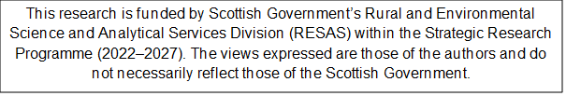

1. Goals derived from [Programme for Government 2023 to 2024](https://www.gov.scot/publications/programme-government-2023-24/pages/14/), [Scotland's National Strategy for Economic Transformation](https://www.gov.scot/publications/scotlands-national-strategy-economic-transformation/), [Land Reform in a Net Zero Nation](https://www.gov.scot/publications/land-reform-net-zero-nation-consultation-paper/), [Scottish Land Rights and Responsibilities Statement 2022](https://www.gov.scot/publications/scottish-land-rights-responsibilities-statement-2022/), [Interim Principles for Responsible Investment in Natural Capital](https://www.gov.scot/publications/interim-principles-for-responsible-investment-in-natural-capital/)
2. Some of the longlisted cases had significant published academic work on them already; others were the current subject of intensive research. The team aimed investigate novel case studies that weren’t overburdened by research demands.