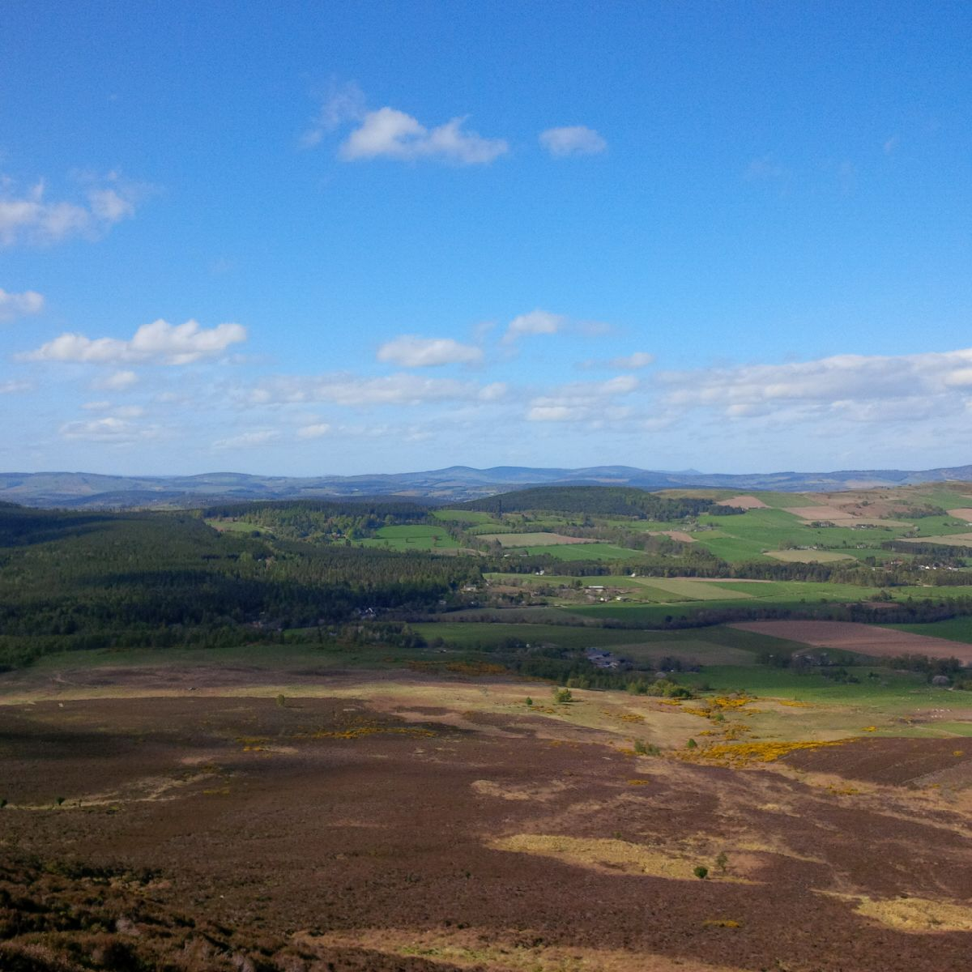thematic(State of Nature Partnership, 2023 #6)

­­­

**Long-term land management for biodiversity: a scoping study**

M 2.10, Milestone report, March 2024

Scotland’s Land Reform Futures project, Rural Futures theme

Acacia Marshall and Annie McKee, SEGS Department, James Hutton Institute

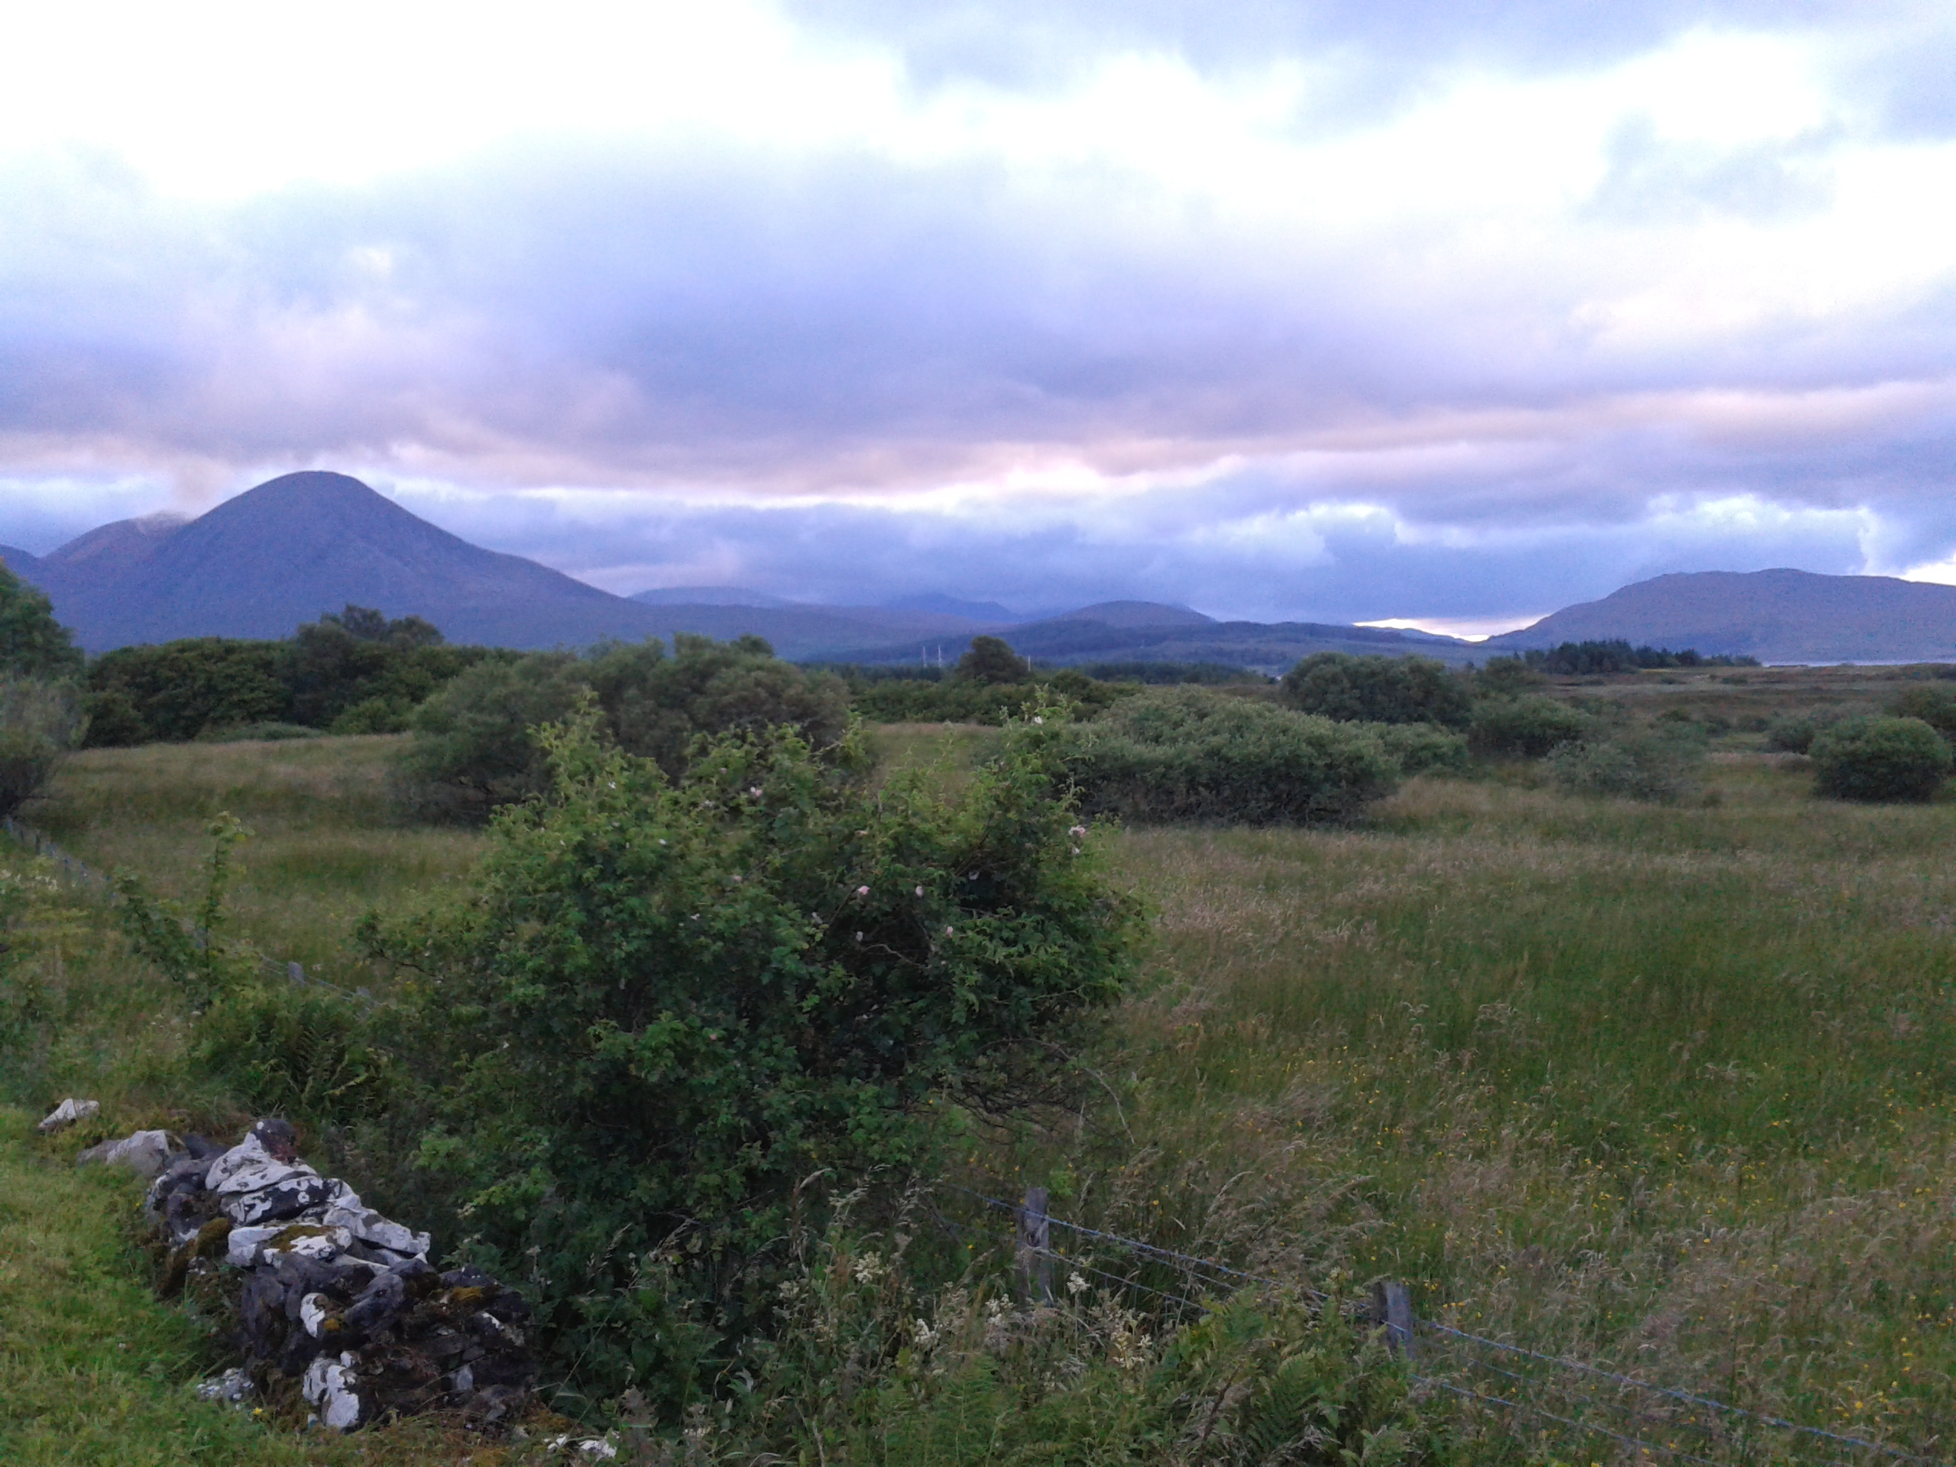March 2024

Photo © Annie McKee

This report was supported by the Rural & Environment Science & Analytical Services Division of the Scottish Government, as part of the Strategic Research Programme 2022-2027.

# Contents

Contents ii

Research context and objectives iv

Highlights v

Executive summary vi

1. Introduction 1

2. Emerging findings 3

3. Next steps 8

References 9

Appendices 10

Contact and feedback 18

**Acknowledgements**

The James Hutton Institute is supported by the Scottish Government’s Rural and Environment Science and Analytical Services Division (RESAS). This research is funded through Scotland’s Land Reform Futures project (JHI-E3-1), part of the Scottish Government's Strategic Research Programme 2022-2027.

The authors gratefully acknowledge the time and expertise provided by the interviewees, and feedback on research design by members of the Stakeholder Advisory Group of the Scotland’s Land Reform Futures project.

# Research context and objectives

The Scottish Government Rural and Environment Science and Analytical Services (RESAS) division funds the [Strategic Research Programme 2022 to 2027](https://www.gov.scot/publications/environment-agriculture-and-food-strategic-research-2022-27-overview/pages/strategic-research-programme-2022-to-2027/) to advance the evidence base in the development of rural affairs, food and environment policies.

One of the themes (Theme E) of the [Strategic Research Programme 2022 to 2027](https://www.gov.scot/publications/environment-agriculture-and-food-strategic-research-2022-27-overview/pages/strategic-research-programme-2022-to-2027/) is on Rural Futures.  This theme has three research topics: rural communities, rural economy and land reform. There are two projects within each topic led by Scotland’s Rural College (SRUC) and James Hutton Institute (JHI). This publication sits within a series of publications as part of this theme.

Within the land reform topic, the two projects are:

1. Impacts of land-based financial support mechanisms on land values, landownership diversification and land use outcomes
2. [Scotland’s Land Reform Futures](https://land-reform-futures.hutton.ac.uk/)

This current research is part of the second project, and it aims to provide a better understanding of:

* The range of mechanisms that exist to support the voluntary adoption of long-term land management approaches aimed at enhancing biodiversity by different landowner types.
* The institutional, financial, social or cultural opportunities supporting, and barriers inhibiting, the uptake of these mechanisms as a voluntary approach to long-term land management for conservation or biodiversity purposes.

Previous publications from the Scotland’s Land Reform Futures project are:

* [Understanding community access to land data](https://www.hutton.ac.uk/sites/default/files/files/Hutton%20-%20Community%20land%20data%20report%20-%20A_McKee%20&%20A_%20Marshall%20revised%202_6_23.pdf)  (March 2023)

[Alternative Land Tenure Models: International Case Studies and Lessons for](https://www.hutton.ac.uk/sites/default/files/files/Alternative%20Land%20Tenure%20Models%20-%20Naomi%20Beingessner,%20Hutton,%20June%202023.pdf) Scotland  (June 2023)

* [Understanding public values of land: A developing typology](https://zenodo.org/records/10689007)  (February 2024)
* Review of Land Ownership Data in Scotland (March 2024)

Please cite as: Acacia Marshall and Annie McKee (2024) *Long-term land management for biodiversity: a scoping study.* Scotland’s Land Reform Futures (JHI-E3-1) Project Milestone (M2.10), March 2024.

# Highlights

**What were we trying to find out?**

The main aim of this research is to learn about the experiences, opportunities and challenges facing the owners of land in undertaking long-term land management for biodiversity enhancement. It seeks to explore the range of different mechanisms used for long-term land management, including management agreements and conservation burdens, and the institutional, financial, or social/cultural opportunities supporting and barriers inhibiting their uptake as a voluntary approach to long-term land management for conservation or biodiversity purposes. The objective is to inform Scottish Government policy around biodiversity, in particular, the Scottish Government’s ‘30 x 30’ target – i.e. the goal to ensure protected areas cover at least 30% of land by 2030, seeking to provide recommendations for enhancing the area of land protected voluntarily by different types of landowners.

**What did we do?**

We undertook a literature review of relevant academic and grey literature, focussed on Scotland and the Global North identified through keyword searches related to the research objectives. We undertook scoping interviews with Scottish Government policymakers, key individuals in government agencies, representatives of stakeholder organisations, and of different landowner types (e.g. private, public, and community landowners) across Scotland. Interviewees were identified through their role and expertise, and where researchers had identified the existence of long-term land management approaches for biodiversity purposes on landholdings managed by the interviewees. A snowball sampling approach supported the recruitment of a purposive sample. At the time of writing, 11 interviews have been completed.

**What did we learn?**

Emerging from interview data is a Land Management Agreements typology that demonstrates a breadth of agreements and approaches in Scotland. They provide a range of incentives to achieve biodiversity enhancement, recognition of ‘good’ practice, and mechanisms through which to meet policy goals. Opportunities and barriers are unique to the differing agreements and approaches, but broad themes are identifiable. Interviewees describe a stewardship mentality amongst landowners, who are managing their land for nature without the necessity of formal agreements. Agreements provide additional incentive financially and through formal recognition. The time and knowledge required can impede landowner engagement, especially in the case of smaller-scale or community landowners. Land tenure type significantly impacts the accessibility and suitability of different agreements and approaches.

**What will happen next?**

In 2024, year 3 of the 5 year research programme, we will undertake thematic analysis of the initial scoping interviews, with the goal of identifying remaining knowledge gaps for further interviews (up to 15 in total). Further thematic analysis will form the basis of a policy briefing report, highlighting the institutional, financial, or social/cultural opportunities supporting and barriers inhibiting uptake of the range of long-term land management approaches for conservation or biodiversity purposes. The policy briefing report will be published in Autumn 2024.

# Executive summary

This report summarises emerging findings from ongoing research into long-term land management agreements relating to biodiversity, in the Scotland’s Land Reform Futures project contributing to the Scottish Government’s Strategic Research Programme (2022-27). The project aims to produce new knowledge regarding land reform, community land ownership and engagement in land-management decision making. It seeks to understand how novel cases of land ownership or governance may be contributing to Scottish Government policy goals, such as net-zero carbon, community engagement and biodiversity enhancement goals such as ‘30 x 30’ .

This milestone report describes research that aims to bring new light to land management practices, in particular long-term land management agreements, that are used to enhance biodiversity and potentially contribute to the ‘30 x 30’ target. Building on research carried out in New Zealand last year, where it was found that ‘Conservation Covenants’ are being used as a means of nature protection, this research began with an interest in the Scottish equivalent, ‘conservation burdens’. Following feedback from the project’s Stakeholder Advisory Group, suggesting that conservation burdens are currently an infrequently used tool in Scotland, this focus was expanded to look at the breadth of management agreements that exist in Scotland. The aim is to explore existing management agreements in Scotland, understand the mechanisms through which they operate, and assess the opportunities and barriers for different land tenure and landowner types to engaging with these tools.

We have completed a desk-based literature review, providing context to our ongoing work, and carried out 11 interviews. Interviews have been with a range of actors including a policymaker, environmental non-governmental organisation (eNGO) representatives, a stakeholder organization representative and representatives of different landowner types such as community, private and public owners. Full analysis of interview transcripts will provide the basis of a policy briefing report, and a land management agreement typology will be presented. This will detail the practicalities of the range of agreements and approaches relating to biodiversity enhancement in Scotland. Institutional, financial, or social/cultural opportunities and barriers will be identified and a set of policy recommendations based on these findings will be made. Emerging is a typology that includes management agreements ranging from Agri-envrionmental Schemes (AECS) and management agreements with NatureScot or Environmental Non-Governmental Organisation to leases, memorandums of understanding and conservation burdens. Opportunities arise from value driven, nature conscious land management, the flexibility offered by some agreements, and financial and accolade-based incentives. Barriers exist around skepticism of the carbon market, a lack of time and knowledge within some organisations to engage with the lengthy process of reaching an agreement and difficulties presented by specific land tenure types.

# Introduction

* 1. **Background**

The latest [State of Nature Report for Scotland](https://www.nature.scot/doc/state-nature-scotland-report) painted a stark picture regarding the continuing nature crisis in Scotland, in particular highlighting an average of 15% decline in species’ distribution since 1994, and that 11% of species are classified as threatened (State of Nature Partnership, 2023). This key report also stated that “*the scale and pace of nature restoration remains inadequate to halt and reverse nature losses*” (State of Nature Partnership, 2023, p. 15). The Scottish Government’s [Biodiversity strategy to 2045: tackling the nature emergency](https://www.gov.scot/publications/scottish-biodiversity-strategy-2045-tackling-nature-emergency-scotland/) sets a goal for Scotland to be ‘nature positive’ by 2030 and to have restored and regenerated biodiversity across the country by 2045 (Scottish Government, 2022). Furthermore, the Scottish Government is committed to Target 3 of the [UN Convention on Biological Diversity’s (CBD) Kunming-Montreal Global Biodiversity Framework](https://www.cbd.int/article/cop15-final-text-kunming-montreal-gbf-221222), summarised as the ‘30 x 30 target’. In more detail, this target requires countries to ensure that “*at least 30% of land and sea is effectively conserved and managed for nature by the year 2030*” (NatureScot, 2023a) In Scotland, the sites that fall within the ‘30 x 30’ target include Protected Areas[1] and Other Effective Area-based Conservation Measures (OECMs). OECMs are defined as:

“*A geographically defined area other than a Protected Area, which is governed and managed in ways that achieve positive and sustained long-term outcomes for the in situ conservation of biodiversity, with associated ecosystem functions and services and where applicable, cultural, spiritual, socio–economic, and other locally relevant values*” (NatureScot, 2023a).

In particular, in accordance with [IUCN guidelines](https://portals.iucn.org/library/sites/library/files/documents/PATRS-003-En.pdf) for OECMs, the area included must be managed to achieve positive and long-term biodiversity conservation outcomes (although not necessarily primarily for biodiversity), and there must be a long-term guarantee of this type of land management approach. NatureScot (2023a) explains that for Scotland this means that areas are categorised as OECMs where land management for biodiversity is undertaken for no less than 30 years, and that agreements for significantly longer periods, or in perpetuity, are encouraged. OECMs represent a mechanism for bringing new areas under long-term conservation, through a ‘bottom-up approach’ of legal or contractual agreements with a range of landowner and land manager types (NatureScot, 2023a).

These Scottish Government policy objectives are also being undertaken with a context of significant land use change relating to climate change (i.e. both the physical impacts and policy drivers to mitigate and adapt to climate change), as well as a new and rapidly-developing natural capital market (Mckee, et al., 2023; Sharma, et al., 2023). New types of landowners are entering the Scottish land market to gain from the opportunities associated with natural capital and in some cases, to invest privately in contributing to nature restoration (e.g. philanthropic individuals and companies undertaking ‘rewilding’) (see: Merrell, et al., 2023). The Scottish Government are seeking to attract private finance to help to overcome reported ‘nature finance gap’ and support landscape-scale restoration (NatureScot, 2023b). There is a need therefore to provide mechanisms that guarantee that land will be managed in the long-term to support nature and enhance biodiversity, and that gains in nature will be recognised (Reid, 2024). This scoping study is also undertaken within a changing policy landscape, not least due to the Agricultural Reform Programme and current passage of the Agriculture and Rural Communities (Scotland) Bill through the Scottish Parliament, in addition to the forthcoming Natural Environment Bill and the [Land Reform (Scotland) Bill](https://www.parliament.scot/bills-and-laws/bills/land-reform-scotland-bill/introduced), all of which will likely influence how land ownership and management is incentivised and regulated to undertake mechanisms that support biodiversity outcomes.

This scoping study seeks to understand the experiences, opportunities and challenges facing the owners and managers of land in undertaking long-term land management for biodiversity enhancement. It aims to explore the range of different mechanisms used for long-term land management, and the institutional, financial, social or cultural opportunities supporting, and barriers inhibiting, their uptake as a voluntary approach to long-term land management for conservation or biodiversity purposes.

* 1. **Approach taken**

We undertook a literature review of relevant academic and grey literature (including policy documents), focussed on Scotland and the Global North, identified through keyword searches related to the research objectives.

A proposal for the scoping study was shared with members of the Scotland’s Land Reform Futures Stakeholder Advisory Group (December 2023), who provided valuable feedback regarding the need to broaden the range of long-term land management agreements that can and do support biodiversity enhancement.

We undertook scoping interviews with Scottish Government policymakers, key individuals in government agencies, representatives of stakeholder organisations, and of different landowner types (e.g. private, public, and community landowners) across Scotland. Interviewees were identified through their role and expertise, and where researchers had identified the existence of long-term land management approaches for biodiversity purposes on landholdings managed by the interviewees. Interviews were conducted online and lasted around one hour. Interviewees were invited to participate anonymously; the interview guide and participant information sheet are provided in Annex 1 and 3. The list below provides an overview of the types of interviewees. A snowball sampling approach supported the recruitment of a purposive sample. The interviews were digitally recorded and transcribed, to allow for thematic coding. At the time of writing, 11 interviews have been completed and are undergoing analysis using NVivo qualitative analysis software.

**Type of interviewees (March 2024)**

The following list includes the full range of interviewee roles that have taken part in a scoping interview:

* Policymaker
* Government agency representative
* Stakeholder agency representative
* Land agency representative/ private consultant
* Representative of private landowner/ private landowner
* Representative of public landowner
* Representative of community landowner
* Representative of environmental non-governmental organisation landowner (ENGO)

**1.3 Structure of the report**

This report provides an overview of the background to this scoping study, in particular the policy context, rationale for research, and feedback received from the members of the Stakeholder Advisory Group for the Scotland’s Land Reform Futures project. The report continues with an outline of emerging findings from the initial interviews completed by March 2024, and the key questions arising for the final interview set. Finally, the report details the next steps with regard to this project, in particular, the preparation of a policy briefing report including recommendations arising from the scoping study to support the voluntary uptake of long-term land management approaches for biodiversity by a range of land manager and landowner types.

# Emerging findings

**2.1 Range and type of long-term land management approaches: A developing typology**

The interviewees were asked to describe the range of long-term land management approaches or other agreements (primarily for biodiversity) that exist in Scotland. Analysis of interview transcripts generated a long list of different types, purposes, durations, and outcomes associated with long-term land management approaches. In conjunction with examples derived from the literature, this long-list has been summarised and categorised, providing a developing typology. The developing typology is presented in Table 1.

**Table 1 – A developing typology of long-term land management approaches/agreements for biodiversity in Scotland**

|  |  |
| --- | --- |
| **Long-term land management approach type** (to be completed after transcript analysis) | **Examples and Key Features** (to be completed after transcript analysis) |
| Agri-environment schemes | * Such as Agri-Environment Climate Scheme (AECS) or public sector or agency driven formal schemes * Conditional and competitive grant from Scottish Government * Agreement in place for up to 5 years. |
| Supermarket/Supplier Contracts | * Legal contract between private businesses in which food producers have an agreement with buyers to deliver certain biodiversity outcomes. * Vary in length, some have to be renewed annually |
| Accreditation schemes | * These schemes provide accolade for certain land management types such as organic farming, wildlife estates and nature friendly farming * Awarding bodies are organisations like Soil Association and Wildlife Estates Scotland * Accreditation opens doors to certain pots of funding and opportunities for product premium * The badge is based upon landowners meeting the requirements of the accreditation scheme |
| Management Agreements | * Include those that are between landowners and NatureScot or eNGOs or those between private parties including private landowners and community groups. * Formally agreed document detailing requirements on the part of both parties * The duration of these vary. Management Agreements with NatureScot are often 5 years in length but this type of agreement can span up to 25 years+. |
| Memorandum of Understanding | * This could exist between a landowner and a community group. * A formal document that details the requirements on the part of both parties. It is not legally binding, it rather states an intention to move forward with a contract. |
| Agreements and Contracts associated with natural capital project | * This includes thing such as participation in the Woodland Carbon Code, the Peatland Carbon Code or voluntary biodiversity credit markets. * This can involve loan agreements (e.g. carbon loans) and standard securities. * Project length varies with a minimum of 30 years[2] for the Peatland Carbon Code and a maximum of 100 years[3] for the Woodland Carbon Code. |
| Leases | * These may be agricultural, sporting or windfarm leases * They are 25-50 years in duration |
| Purposes and obligations embedded within charitable trusts | * Charitable trusts that own/manage land must fulfil their charitable objectives relating to biodiversity and nature. |
| Conservation Burdens | * Agreement between landowner and external party; applied as title burden which binds current and future landowners to undertake land management for conservation. * Last in perpetuity, unless the agreement is terminated by both parties through a Lands Tribunal. |
| Protected Area Status | * Formal designation of land determined by the Scottish Government * Last in perpetuity |

This emerging typology demonstrates the variety of long-term land management approaches that currently exist in Scotland. Once interview transcripts have been analysed, additional management agreement types will be added, as well as further detail of the mechanics of each. So far, it is evident that a large range of agreement types exist, offering differing incentives and levels of flexibility to landowners who engage. Through the process of transcript analysis and further interviews, we will seek to gain further nuance, defining the outcomes that these approaches seek to produce and their scale in a Scottish context. Currently, we do not possess a full picture of where these land management approaches are taking place, and if they are in areas important for biodiversity, which could be significant for the development of OECMs. In some cases (e.g. property burdens) this is due to the partial coverage of landownership data (Miller, et al., 2024). Further analysis will allow us to pinpoint key policy messages and bring to light recommendations that will encourage the voluntary uptake of these agreements and approaches.

**2.2 Opportunities and barriers to uptake across diverse landownership types (i.e. differences in experiences and perspectives)**

The breadth and nuance of these land management agreements result in diverse opportunities and barriers, specific to each type of agreement. At the time of writing this, we have not received most of the interview transcripts, and they have not yet been analysed. Therefore, the following opportunities and barriers, based on researcher notes, are a snapshot rather than a full picture of the interview data so far.

Value-based decision-making offers an opportunity in terms of managing land for biodiversity enhancement. Several interviewees emphasise this as a driving force behind sustainable land management practices, without the necessity for formal management agreements. Rather, stewardship is embedded within landowner objectives. An integrated approach that delivers for people, jobs and nature, is taken by many landowners, meaning that environmental benefits are embedded into management practices. Additionally, there is the recognition amongst some private landowners that working with nature is not only beneficial for the environment, but also business. Philanthropic approaches, although varying in their exact nature, encompass different land-owner types; communities, private landowners, crofters as well as public sector owners are cited as being engaged with biodiversity enhancement in connection with a stewardship mentality. However, one interviewee highlighted that scale and diversification of interest influence landowner ability to act upon these values. Larger scale landholdings do not need as concentrated economic yield, allowing space for biodiversity enhancement underpinned by the financial success of other areas of their land. Estates are more likely to have a diversified income stream, permitting profit generated to be reinvested into nature.

For some, financial support can enable these values to become a reality, providing incentive for landowners to engage with the breadth of agreements and schemes outlined above. The carbon market offers an incentive for some landowners, for example those that own land particularly suited to woodland or peatland. Considering the changing financial incentives in Scotland, those that have previously farmed land or managed it for sporting, may choose to transition management practices in order to follow more lucrative opportunities offered by carbon sequestration. A biodiversity market has the potential to provide an ongoing payment for landowners, as opposed to the one off payment offered for the selling of carbon credits. The groundwork for this mechanism is not yet in place, and there are no defined contracts. However, there is reportedly conversations about partnerships between landowners and biodiversity credit providers happening, so this may emerge as a mechanism in the future.

Management Agreements, such as those offered by NatureScot, and Agri-Environmental Schemes (AECS) are generally for a time span of 5 years. Some interviewees suggested that this timeframe allows for flexibility which is attractive to landowners. It gives time for impact but does not rule out other goals or commitments. Landowners engaged in agri-environmental schemes will often reapply, meaning that longer term schemes can be realised.

Accolade through accreditation schemes provide an additional incentive for landowners to engage in biodiversity enhancing land management. Although the basis of this engagement may be philanthropic, the badges awarded to landowners do offer a way to publicise their land management. This includes approaches such as organic and nature friendly farming and wildlife estates. Financially, accreditation schemes can open the door to certain funding avenues as well product premium on resources that the land offers, such as tourism or food.

The National Planning Framework (NPF) 4 was mentioned by one interviewee as having the potential to provide opportunity for engagement from landowners with biodiversity token unit trades. In cases where landowners neighbour areas where significant developments are happening, landowners may be able to engage with developers and local authorities to calculate the estimated biodiversity loss from a given development and implement practices that will restore this. Similarly, compensatory planting is a mechanism used in cases where companies are carrying out construction, for example of electricity transmission lines, that cause land degradation. Under this mechanism they can partner with the landowner, plant trees on their land and pay them for the foregone carbon credits. With the growing need for electricity connectors across Scotland, it was suggested that the use of this mechanism is likely to increase.

Collaboration between landowners has the potential to enable larger-scale land management changes and increase commitment to biodiversity goals. The examples of farming clusters and Monitor Farms were given to illustrate how accountability to others can result in longer-term engagement.

A significant barrier mentioned by several interviewees is the lengthy time and bureaucracy involved in reaching an agreement. One interviewee described complex legal discussions that preceded a long-term land management agreement being met, and the excessive amount of time that this had taken was emphasised. Added to this is that some landowners lack knowledge, access to advice, resources and volunteer capacity that are necessary to engaging with schemes and getting applications ‘right’. Indeed, smaller farms are often outside of schemes, which could be due to lower resources and therefore lower capacity to engage. The amount of risk involved may also be greater for certain landowner types, such as community landowners, where ‘things going wrong’ could result in personal loss of assets.

In terms of the carbon market, as previously mentioned, it offers a one-off payment for the sale of carbon credits. The nature of this is potentially off-putting, and one interviewee highlighted this as a problem that needed to be solved in order to make the carbon market more attractive to landowners. There is also scepticism amongst some relating to ‘green-washing’. Some landowners are hesitant to engage with large corporations such as Amazon or Shell, who are able to continue releasing emissions while using others’ land to off-set this.

Though the 5 year contracts offered by some schemes provide landowners with a flexible option for management, others suggested that this timeframe does not allow for real impact. There was scepticism amongst some interviewees that 5 years provides enough time for habitat restoration and some suggested that this should be increased to at least 10 or 20 years, proportional to the size of the project. Agri-environmental schemes were described as maintaining the status quo, which can work when good practice is already being employed, but it was suggested that the management agreements offered by Nature Scot encourage specific management better. However, organisations such as Nature Scot may be hesitant to enter into longer term agreements when their budget is managed on an annual basis, and the pot of funding is limited.

Land tenure type has a large impact on the accessibility of these schemes. For those with shorter-term tenancies, it is unclear whether incentives for biodiversity enhancement work as well, especially if they are not part of the landowners’ land management plans. Indeed, entering into agreements such as AECS can be difficult for tenants in the case of unwilling landowners. Crofting communities may find these agreements difficult to engage with, due to the nature of common grazings. With multiple users who have individual aspirations, reaching agreements on land management changes can be difficult, especially when decisions include both active crofters and absentee or shareholder crofters. The rights and responsibilities associated with common grazings may disincentivise or be a complete barrier to engaging with some agreements. The multiple actors involved in community groups can make engagement from community landowners more convoluted, and each community group is different in their aspirations. Private landowners are also heterogeneous in their ambitions, some may be supportive of schemes and others resistant; absentee landowners can present a difficult group to engage with. Within the agricultural community there is also disagreement, with some keen to tap into public funding and others concerned about the impact on their livelihood if restrictions are imposed on their land. Barriers are specific to these different land tenure types and therefore it is vital to take this into account when considering the viability of long-term land management agreements.

# Next steps

Between April 2024 – March 2025, which is Year 3 of the 5-year programme on Scotland’s Land Reform Futures project, a thematic analysis of the initial scoping interviews will be undertaken, with the goal of identifying remaining knowledge gaps for further interviews (up to 15 in total). A second phase of thematic analysis (when all the interviews are completed) will form the basis of a policy briefing report, highlighting the institutional, financial, social or cultural opportunities supporting, and barriers inhibiting, uptake of the range of long-term land management approaches for conservation or biodiversity purposes. Key policy messages will be extracted throughout the process of interview data analysis and will be presented as recommendations to support the voluntary uptake of long-term land management approaches for biodiversity by a range of land manager and landowner types in Scotland. The policy briefing report will be published in Autumn 2024.

# References

Mckee, A., Beingessner, N., Pinker, A., Marshall, A., Currie, M., & Hopkins, J. (2023). *The Social and Economic Impacts of Green Land Investment in Rural Scotland.* Scottish Government. Retrieved from https://www.gov.scot/binaries/content/documents/govscot/publications/research-and-analysis/2023/12/social-economic-impacts-green-land-investment-rural-scotland/documents/social-economic-impacts-green-land-investment-rural-scotland/social-economic-impacts-

Merrell, I., Pate, L., Glendinning, J., & Thomson, S. (2023). *Rural Land Market Insights Report 2023.* Retrieved from https://www.landcommission.gov.scot/downloads/645cda7a2ba61_Rural%20Land%20Markets%20Insights%202023.pdf

Miller, D., Matthews, K., Wardell-Johnson, D., & Mckee, A. (2024). *Review of Land Ownership Data in Scotland.* The James Hutton Institue.

NatureScot. (2023). *£2 billion private finance pilot potential ‘vital step in restoring Scotland’s woodlands’.* Retrieved from https://www.nature.scot/ps2-billion-private-finance-pilot-potential-vital-step-restoring-scotlands-woodlands

NatureScot. (2023). *Framework for 30 by 30 in Scotland - Draft.* Retrieved from https://www.nature.scot/sites/default/files/2023-09/Framework%20for%2030%20by%2030%20in%20Scotland%20%E2%80%93%20Draft_1.pdf

Reid, C. (2024, January). Conservation Burdens and Harvesting Natural Capital. University of Dundee.

Scottish Government. (2022). *Biodiversity Strategy to 2045: tackling the nature emergency.* Scottish Government. Retrieved from https://www.gov.scot/binaries/content/documents/govscot/publications/strategy-plan/2022/12/scottish-biodiversity-strategy-2045-tackling-nature-emergency-scotland/documents/scottish-biodiversity-strategy-2045-tackling-nature-emergency-scotland/scottish-bio

Sharma, K., Walters, G., Metzger, M. J., & Ghazoul, J. (2023). Glocal woodlands – The rescaling of forest governance in Scotland. *Land Use Policy*. Retrieved from https://www.sciencedirect.com/science/article/pii/S0264837722005518

State of Nature Partnership. (2023). *State of Nature Report.* Retrieved from https://stateofnature.org.uk/wp-content/uploads/2023/09/TP26056-SoN-Scotland-summary-report-v5-1.pdf

# Appendices

**Annex 1**

All participants were sent Participant Information sheets prior to taking part in interviews.

**Annex 2**

Prior to being interviewed, all participants were sent a consent form and asked to return it.

**Annex 3**

One Interview Guide is used for landowners and the other is used for policy makers, government agencies and other key stakeholders

# Icon Description automatically generatedContact and feedback

Acacia Marshall: [acacia.marshall@hutton.ac.uk](mailto:acacia.marshall@hutton.ac.uk)

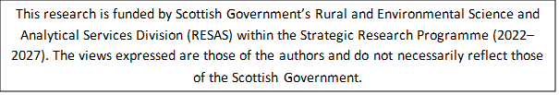

1. Protected Areas in Scotland include Sites of Special Scientific Interest (SSSI), European sites, Ramsar sites, or National Nature Reserves (NNR).
2. [How it works | IUCN UK Peatland Programme (iucn-uk-peatlandprogramme.org)](https://www.iucn-uk-peatlandprogramme.org/peatland-code/how-it-works)
3. [1.1 Key project dates - UK Woodland Carbon Code](https://woodlandcarboncode.org.uk/standard-and-guidance/1-eligibility/1-1-key-project-dates)